Into the air

A loudspeaker vibrates and makes a sound.
We hear the sound because it moves through the air.


These pictures try to show how sound moves through the air.
Which one is the best model for how sound moves?

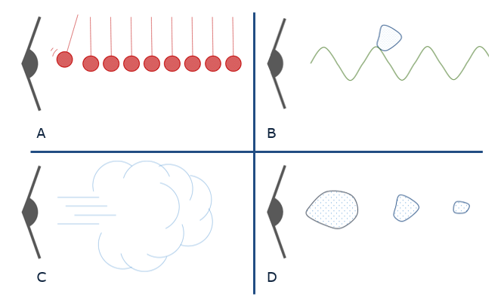

Physics > Big idea PSL: Sound, light and waves > Topic PSL1: Sound and light > Key concept PSL1.1: Production and transmission of sound
Diagnostic question
Into the air

Overview
Learning focus: | Objects and materials can be made to vibrate to produce a sound that becomes louder as the size of vibration increases and higher pitched as the rate of vibration increases.
Observable learning outcome: | Explain how vibrations are passed on to the surrounding air.
Question type: | Simple multiple choice
Key words: | Vibrate, vibration

What does the research say?
The transmission of sound is difficult to understand. It is common for students to think of sound a material substance that moves from one place to another (Barman, Barman and Miller, 1996). Even at degree level Linder (1992) found that some students thought of sound as a ‘lump’ of material travelling through a passive medium, similar to a surfer on a water wave.
In his study of twenty-eight 11-14 year olds Whittaker (2012) found that fewer than 30% used the idea of vibrations to correctly describe how sound travels through air. Half the students believed a gap around the door was necessary for sound to enter from the outside, which indicates a view of sound as a material substance. Only 20% were able to explain how sound vibrations can pass through the wall.
40% of students in the same study thought sound got quieter as it travelled further because it ‘faded and died out’ or ran out of ‘energy’.
This question can help to identify whether students have a scientific understanding that can be used to explain how sound travels or whether they hold any of these misunderstandings.
Ways to use this question
Students should complete the question individually. This could be a pencil and paper exercise, or you could use an electronic ‘voting system’ or mini white boards and the PowerPoint presentation.
The answers to the question will show you whether students understood the concept sufficiently well to apply it correctly.
If there is a range of answers, you may choose to respond through structured class discussion. Ask one student to explain why they gave the answer they did; ask another student to explain why they agree with them; ask another to explain why they disagree, and so on. This sort of discussion gives students the opportunity to explore their thinking and for you to really understand their learning needs.

Differentiation
You may choose to read the questions to the class, so that everyone can focus on the science. In some situations it may be more appropriate for a teaching assistant to read for one or two students.
Expected answers
Correct answer is A
How to respond - what next?
Answer A shows a series of particles bashing into each other and is the best of these models. It shows the first particle being ‘bumped’ by the vibrating speaker and then passing the ‘bump’ along. It is inaccurate because in the air there are many, many more particles passing on the vibration, and they are not hanging on strings. In fact there are roughly five thousand times more particles in each centimetre cubed of air, than number of seconds in the entire history of the universe so far!
B shows the ‘surfer model’ with a lump of sound being pushed through the air by a wave of air particles. Many students have heard about sound waves and this model is often used fit the idea of vibrating air particles into a misunderstanding that sound is a material substance.
C shows the sound moving as a gust of air, and D as a material substance moving through the air that ‘fades out’ as it moves.
If students have misunderstandings about how sound travels, it might be helpful for them to be given the opportunity to explain why the other models are wrong. Working in pairs or small groups can encourage social construction and consolidation ideas through dialogue.
The following BEST ‘response activity’ could also be used in follow-up to this diagnostic question:
- Response activity: Sound model
Acknowledgments
Developed by Peter Fairhurst (UYSEG).
Images: UYSEG
References
Barman, C. R., Barman, N. S. and Miller, J. A. (1996). Two teaching methods and students' understanding of sound. School Science and Mathematics, 96(2), 63-67.
Linder, C. J. (1992). Understanding sound:so what is the problem? Physics Education, 27, 258-264.
Whittaker, A. (2012). Pupils think sound has substance - well, sort of ... School Science Review, 94(346), 3.

